**EXPERIMENT 3. CHEMICAL KINETICS**

**PART A. DETERMINATION OF A RATE LAW**

1. Access the Iodine Clock Reaction experiment at the website below:

[**http://web.mst.edu/~gbert/IClock/Clock.html**](http://web.mst.edu/~gbert/IClock/Clock.html)

1. Check that your settings match those shown below, then click “Mix the Solutions”:

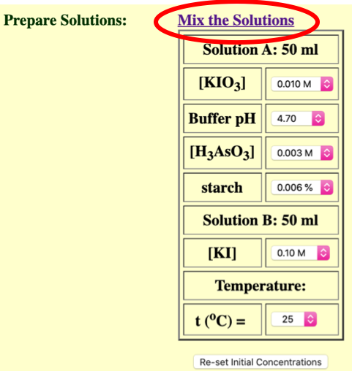

1. Click “start” to mix Solutions A and B, then *as soon as the reaction mixture turns blue*, click “stop timer” and record the time of your reaction in the “**Trial 1**” row in Q1 of your Lab Report. (If you miss the exact moment of color change, click “ReSet” to run the reaction again.)

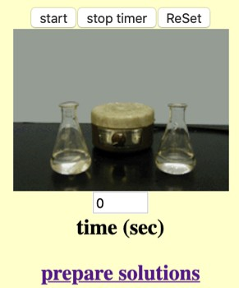

1. Click “prepare solutions” to return to the solution prep page.
2. Repeat the simulation three additional times (“**Trial 2”**, **“Trial 3”** and **“Trial 4**”), preparing each of your solutions as described below; be patient, as some of the reactions take longer than others! Remember to record the reaction times in Q1 of your Lab Report.

**Trial 2 Trial 3 Trial 4**

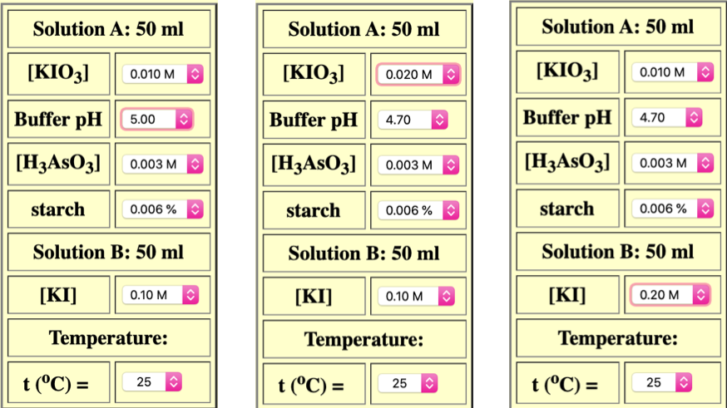

**PART B. DETERMINATION OF ACTIVATION ENERGY**

1. From the solutions prep page, select “Re-set Initial Concentrations” and check that your values match those shown below. Mix the solutions and record the reaction time in the “**25ºC**” row in Q8 of your Lab Report.

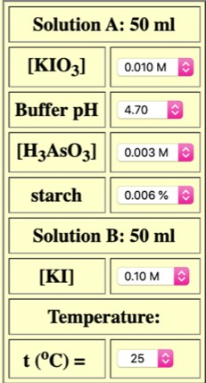

1. Repeat Step 6 two additional times, first changing the temperature to **35ºC**, then to

**45ºC**. Remember to record the reaction times in Q8 of your Lab Report.

**LAB 3 REPORT STUDENT: *YOUR NAME HERE***

# Part A. Determination of a Rate Law

Q1. Record the time required for each of your solutions trials in Part A to turn blue:

|  |  |  |  |
| --- | --- | --- | --- |
| **KIO3 in 50 mL** | **Buffer pH** | **KI in 50 mL** | **Time (s)** |
| **0.010 M** | **pH 4.70** | **0.10 M** |  |
| **0.010 M** | **pH 5.00** | **0.10 M** |  |
| **0.020 M** | **pH 4.70** | **0.10 M** |  |
| **0.010 M** | **pH 4.70** | **0.20 M** |  |

**Trial 1**

**Trial 2**

**Trial 3**

**Trial 4**

Q2. *(4 pt)* Complete the table below, showing sample calculations for your Trial 1 data:

|  |  |  |  |
| --- | --- | --- | --- |
| [𝐼𝑂%] **in 100 mL**  $  **final mixture** | **[H+]** | **[I–] in 100 mL**  **final mixture** | **Rate** |
|  |  |  |  |
|  |  |  |  |
|  |  |  |  |
|  |  |  |  |

**Trial 1**

**Trial 2**

**Trial 3**

**Trial 4**

*Sample calculations of [*𝐼𝑂%*], [H+], [I–] and rate (Trial 1):*

$

Q3. *(1 pt)* Determine the reaction order with respect to 𝐼𝑂%, showing your work below; round

$

your answer to the nearest half or full integer:

Q4. *(1 pt)* Determine the reaction order with respect to H+, showing your work below; round your answer to the nearest half or full integer:

Q5. *(1 pt)* Determine the reaction order with respect to I–, showing your work below; round your answer to the nearest half or full integer:

Q6. *(1 pt)* Write the full rate law for this reaction:

Q7. *(2 pt)* Calculate the rate constant, k, *including units*, for each of your four trials, then calculate the average value of k; show all work:

# Part B. Determination of Activation Energy

Q8. Record the time required for each of your solutions trials in Part B to turn blue:

|  |  |  |  |
| --- | --- | --- | --- |
| **KIO3 in 50 mL** | **Buffer pH** | **KI in 50 mL** | **Time (s)** |
| **0.010 M** | **pH 4.70** | **0.10 M** |  |
| **0.010 M** | **pH 4.70** | **0.10 M** |  |
| **0.010 M** | **pH 4.70** | **0.10 M** |  |

**25ºC**

**35ºC**

**45ºC**

Q9. *(2 pt)* Complete the following table, showing sample calculations for your 25ºC data:

|  |  |  |  |  |
| --- | --- | --- | --- | --- |
| [𝐼𝑂%]  $ | **[H+]** | **[I–]** | **rate** | **k** |
| **0.005 M** | **2.0 × 10–5 M** | **0.05 M** |  |  |
| **0.005 M** | **2.0 × 10–5 M** | **0.05 M** |  |  |
| **0.005 M** | **2.0 × 10–5 M** | **0.05 M** |  |  |

**25ºC**

**35ºC**

**45ºC**

*Sample calculations of rate and k (25ºC):*

Q10. *(2 pt)* Use Excel, Google Sheets or a similar program to an Arrhenius plot from your temperature data, where your graph must include a proper title and labeled axes, as well as the equation of the linear trend line and its R2 value. Add a blank page to the end of this lab report, then paste your graph onto that page.

Q11. *(1 pt)* Calculate the activation energy ' () - for your reaction:

*+,